**Business Requirements Document**

**Project: eVal Implementation**

**BRD Title: eVal Reports**

**BRD: #3**

**Development required by:**

**Washington State’s eVal Team**

**BACKGROUND**

This Business Requirement Document (BRD) is part of a set of business requirement documents that are part of the Seattle School District’s 2015 implementation of Washington State’s online evaluation tool, eVal. eVal is an online tool developed by the State to support teacher professional growth in alignment with Washington State’s mandates for TPEP (Teacher Principal Evaluation Process). The project goal is to successfully integrate this tool into the District’s TPEP activities, adhering to the District’s obligations of its CBA and to the spirit of the TPEP process which is aimed at fostering professional growth through collaborative, face-to-face discussions between teacher and evaluator.

BRDs related to eVal functionality have been submitted to the State’s eVal development team. BRDs related to back-office activities which require District development have been submitted to DOTs (the District’s development team). Where noted, several of these documents require review and collaboration from both teams.

*For further information, please see Excel file “eVal Seattle - Enhancements and BRD Index” which contains listing of each enhancement that has been approved for development and the related BRD and assigned development team.*

| Version No. | Date | Name | Description of Change |
| --- | --- | --- | --- |
| 1 | 10/31/14 | Donna Schmidt | Baseline; submitted to for review to eVal, DOTs and HR teams |
| 2 | 11/19/14 | Donna Schmidt | Misc. word smithing per stakeholder review (no material changes); updated Review/Approval table to reflect current status |

# High Level Requirement Description

These requirements are related to changes being requested to reports (or report settings) within eVal.

# Business Objective

The requirements in this document will bring the eVal reports into compliance with District CBA language and spirit of District’s TPEP process

# Business processes impacted by the change

The TPEP processes related to observation and evaluation reports.

# Requirement Details

|  |  |  |
| --- | --- | --- |
| ID | Requirement | Purpose or expected outcome |
| 3.1 | Need the eval report titled “Score Alignment Report” hidden or removed from the Self Assessment module (ideally, as a District-wide configuration setting). | The District is concerned that the report infers an accountable connection between the self assessment and the final evaluation which does not currently exist in the District CBA or TPEP processes. Also, the District is concerned that the title of this report has a negative, compliance feel.  Therefore, the ability to hide this report at a District level is requested. |
| 3.2 | Obervation reports and Evaluation reports should not make any reference to a data entry field if a value for that field is not provided by the user, nor to a reporting section if that section was not selected for the report. Specifically, the report should not say “No information provided” for a missing field, nor say “Session Recommendations  No responses found” if the user has not chosen to include Session Recommendation, nor say “Post-Conference Prompts  No prompts with responses found” if the user has not chosen any prompts, etc. | [Note: this requirement may not be needed if the report only refers to missing information if the user chose that information in Print Settings]  Given the size of the District, many teachers will “learn” the TPEP process by using the eVal tool, despite the best efforts of the District to provide dedicated TPEP training. Therefore, if a report displays a data entry field, and the field has no value because it was not filled in by the user, many users will assume that they *should have* filled in that field and that the field is required by the District. The same goes for a section on the report. If a user choses not to include Prompts in their process, for example, then if the Observation Report says “No Prompts included”, then it is inferred that prompts *should have been* included. Furthermore, the District is trying to implement eVal in the simplest manner possible by not requiring the teacher to use any functionality but that which is critical for generating an evaluation report. The District is also trying to reduce administrative time for the evaluator. However, showing the empty fields on the report will lead many teachers and evaluators who are trying to follow the rules to think they should go back and enter data into all of those fields or include the missing sections.  Desired outcome: Online or paper printed reports will not contain reference to fields that are not filled out by the user or sections that were not selected for the report. Nor will the absence of reference to these fields or sections create rows of empty space these references would otherwise have appeared. |
| 3.3 | The Observation report should have a default print setting selected District-wide by the District. | The tool currently allows a user to select a variety of content, making the resulting report short or long. The District is concerned that users will find this confusing, as the choice implies that “more is better” when that may not be the case.  Consequently, the District will be able to set as a District-wide setting those specific items which should always appear on the report. The user can then, at their discretion, add additional items should they choose to do so. |
| 3.4 | Wherever the pencil and scissors icons currently appear throughout the Observation UI or Observation report, they should be replaced with descriptive text. | The District has received feedback from pilot users that the icons are not intuitive. (*Ideally, these would be replaced on the UI and the reports, but if removing it from the UI is too great a work effort, than at least removing it from the Observation and Evaluation reports.)*  *[Exact descriptive text to be defined by further discussion between State and District…. Donna]* |
| 3.5 | The Evaluation report should have a default print setting selected District-wide by the District. | Same as 3.4 (but for the Evaluation report)  The setting for the Evaluation report should allow the District the ability to select *no settings at all* so that the default report contains State Criteria and Student Growth scores only and no other content. |
| 3.6 | The pencil and scissors icons should be removed from the Evaluation report and replaced with descriptive text. | The District has received feedback from pilot users that the icons are not intuitive. Additionally, as the final evaluation report is an official, formal document for the teacher and becomes part of the personnel file, and in cases of dispute would be provided to the court, the District would prefer a less informal look and feel.  Exact descriptive text to be defined by further discussion between State and District. |

**ILLUSTRATION– 3.1**

*Ability to remove or hide the Score Alignment Report.*

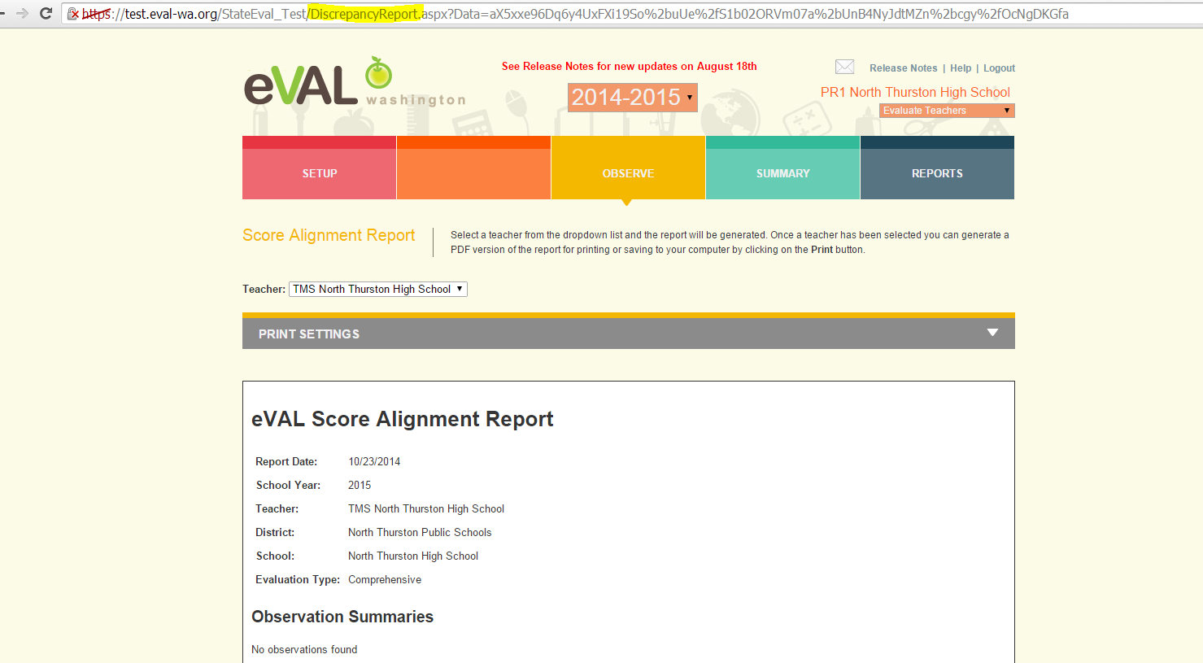

**ILLUSTRATION – 3.2**

*If a user does not select a section for their report, there should be no reference to it. If a user does not fill in a data entry field, there should be no reference to it on the report.*

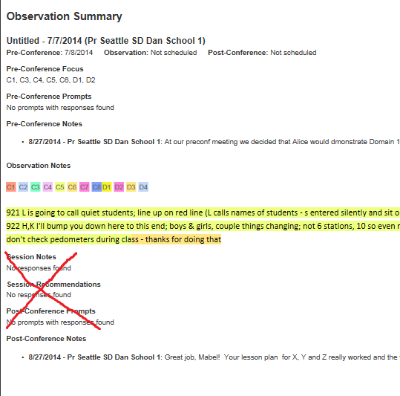

**ILLUSTRATION – 3.3**

The Observation report should have a default print setting selected District-wide by the District.

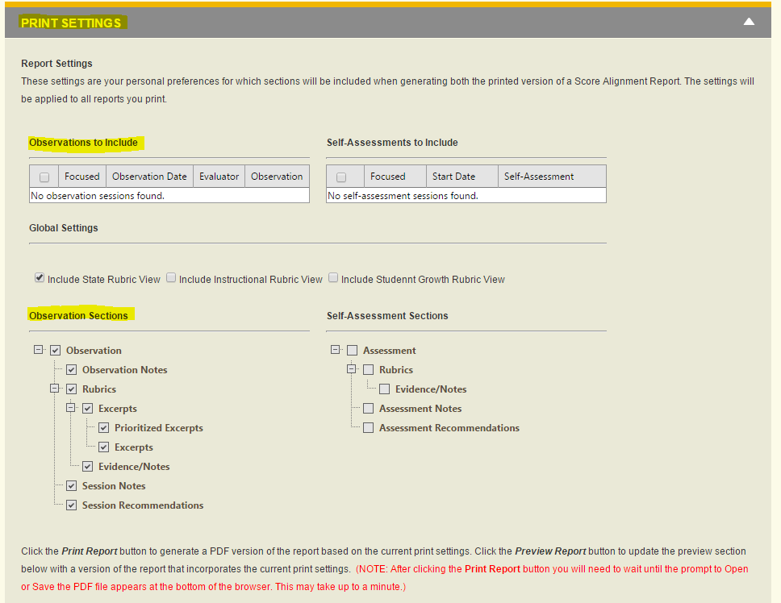

**ILLUSTRATION – 3.4**

*The Pencil and scissors icons should be replaced with descriptive text. Ideally, these would be replaced on the UI and the reports, but if removing it from the UI is too great a work effort, than at least removing it from the Observation and Evaluation reports.*

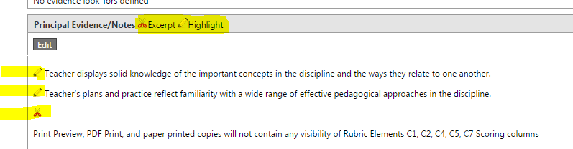

**ILLUSTRATION – 3.5**

The Evauation report should have a default print setting selected District-wide by the District.

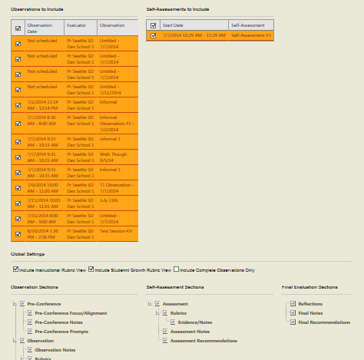

# Review and Approval

| Team | Person | Organizational and Project Roles | Role | Date review/approval received |
| --- | --- | --- | --- | --- |
| Project | Clover Codd | Exec Director Strategic Plan & Partnerships; **Project Sponsor** | Approve project deliverable | 11/5/14 |
| HR | Brent Jones | Asst Superintendent for Human Resources; Project Steering Committee representative for HR; Internal customer for many of the technology updates requested in these documents | Approve project deliverable | 11/19/14 |
| HR | Elaine Williams | Subject matter expert representing Labor Employee Relations Team | Review | 11/14/14 |
| HR | Denise Williams-Saunders | Subject matter expert representing Labor Employee Relations Team | Review | 11/14/14 |
| HR | Sue Means | Subject matter expert representing Labor Employee Relations Team | Review | 11/14/14 |
| DOTs | Nancy Petersen | Director, Enterprise Applications | Informational | 11/6/14 |
| DOTs | James Bradley | Manager, Business Applications | Informational | 11/6/14 |
| DOTs | Mabel Mah | Sr Business Analyst (SAP/HR); project systems analyst representing DOTs for design and development | Review and accept as milestone deliverable | 11/14/14 |
| eVal Dev Team | Anne Chinn | Lead eVal Developer | Review and accept as milestone deliverable | 11/7/14 |
| eVal Dev Team | Dana Anderson | eVal Supervisor/ Project Manager | Review and accept as milestone deliverable | 11/7/14 |